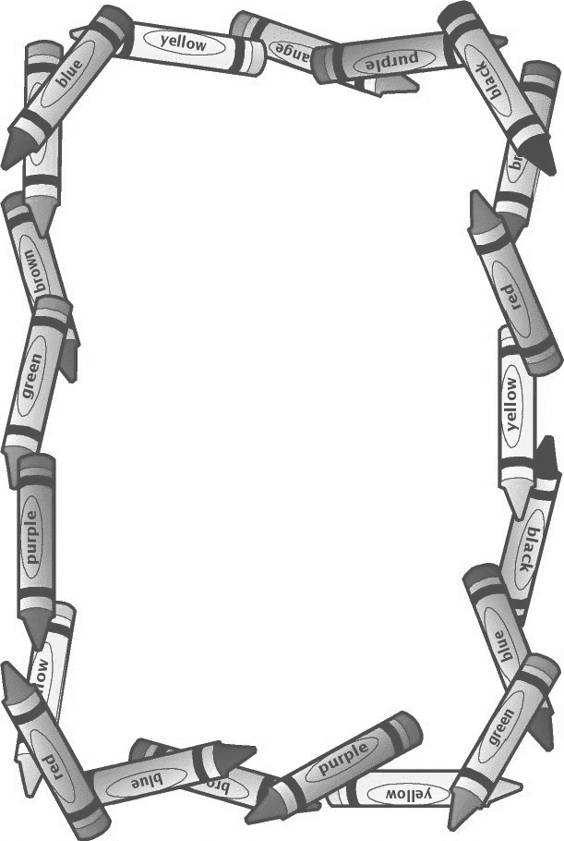

**First Grade Supply List**

* 1 pencil pouch
* 2 spiral 1 subject notebooks
* 3 plastic 3 prong folders
* Crayons
* Pencils
* 1 pair of scissors (round tip)
* glue sticks (No bottled glue)
* Cap erasers or large erasers
* Pack of dry erase markers with eraser
* Headphones (to be kept at school)
* Ziploc bags (gallon and sandwich)
* Copy paper (1 pack white and 1 pack colorful)
* Boxes of tissue
* Hand sanitizer
* Lysol Wipes or Spray
* Roll of paper towels
* Band-Aids

If you would like to send in any extras for students that may not have something, it will greatly help the teachers out! You do not need to label these.

**We can always (but especially this year) use extra hand sanitizer and cleaning supplies in general.**

**Thank you!**

**First Grade Teachers**

**-**